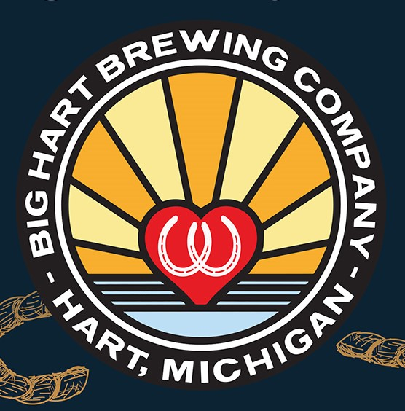

Big Hart Brewing Company 3rd Annual Kentucky Derby Party
Run for the Noses “Horse Race” for Charity Saturday May 5th at 4pm
Registration form must be turned in by Saturday April 28th
You may turn in the form at the brewery or email it to phil@bighartbrewing.com

Team Name:
Name of Jockey: Email address:
Name of Horse: Email address:
Charity you are racing for:

